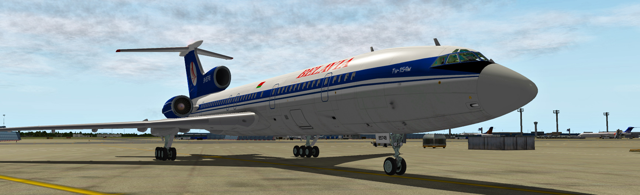

Tu-154M

Technical manual

Table of contents
Install and activation 2
Installing KLN-90B 5
Setting up Cold&Dark mode 6
Moving in cockpit 7
Changing language of panels and settings reset 7
Setting up joystick buttons 8
Commands list 9

Install and activation
To install the airplane you need to unzip the package into this folder:
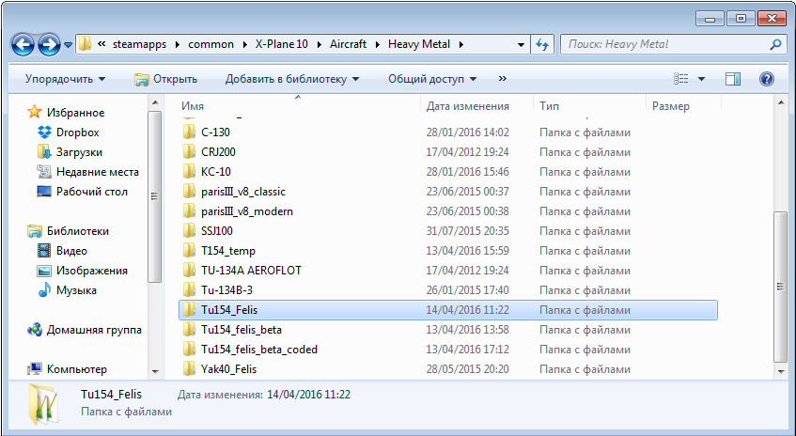
/X-Plane 10/Aircraft/Heavy Metal/

At the very first launch, this model will ask for activation
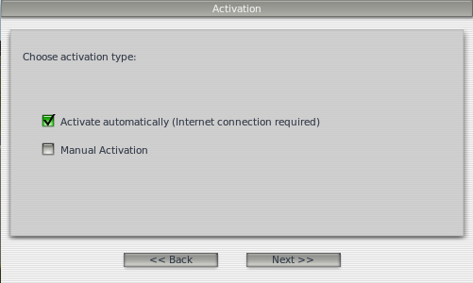
Select Activate automatically. In the next window you'll have to enter your serial number, that you've got in the store along with the model.
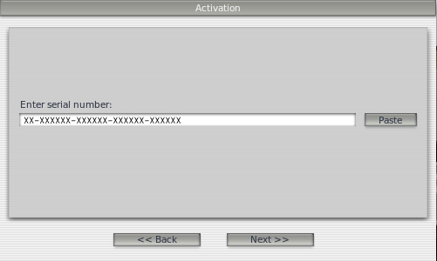
Press «Next>>» and if the activation was successful, you'll see the window, asking you to re-load the aircraft. It is recommended to reopen the aircraft, using the simulator's menu.
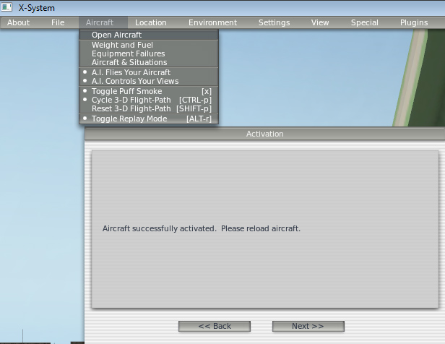

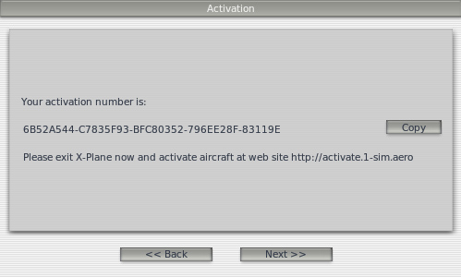
If you have some problems with connection, you'll have to use manual activation. To do so, select «Manual activation» at the first window. Then you'll have to enter your serial number.

It will generate you special activation number, that you need to save. Next, in any awailable internet cafe, you'll have to go to http://activate.1-sim.aero and enter this code and your serial number there. The site will generate you two files: «serial.key» и «aircraft.key», which you'll have to save and copy into the aircraft's main folder.
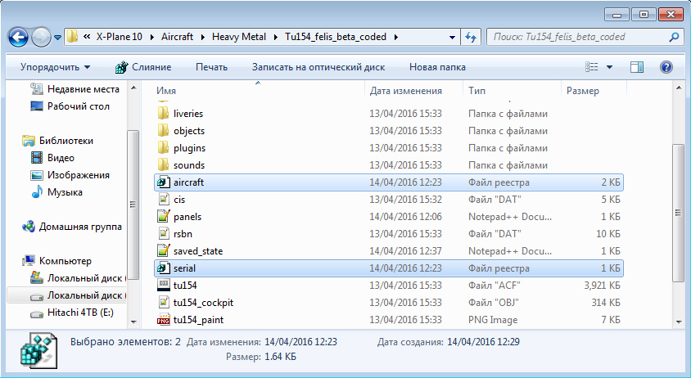

Installing KLN-90B
KLN-90B is the third party software, developed by Dennis Pruefer (http://eadt.eu/) and by his will, it's distributed separately. To work with Tu-154M you will need a special encrypted version, modified specially for this project - http://felis-planes.com/upload/tu154/KLN90_Tu154.ZIP
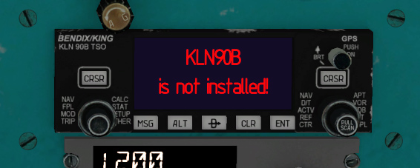
If, when open an aircraft, you see this:
then you need to download and install it.
Inside the package you will find two folders: «KLN90» and « X-Plane main folder». Files from the first one you'll need to copy into /Custom Avionics/KLN90/ your acf folder, replacing files inside it, and from second – into the simulator's root folder. If you already used KLN in other projects, like An24, yu don't need to copy file from second folder.
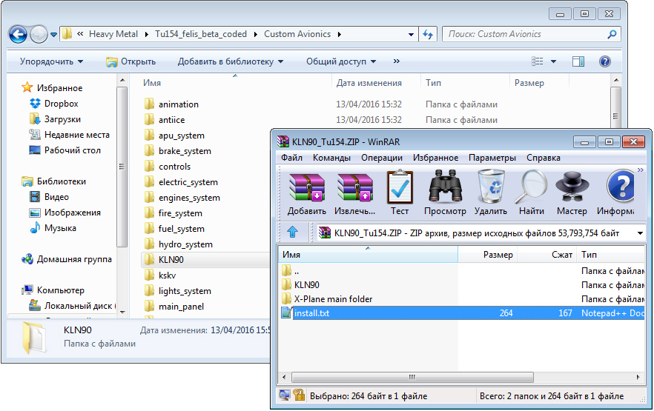

Setting up Cold&Dark mode
Изначально, X-Plane настроен так, что самолеты в нем открываются с уже запущенными двигателями и включенными приборами и системами. Если вы хотите при открытии самолета видеть его в состоянии Cold&Dark – вам перейти в меню Settings → Operations & Warnings и там установить галочку «start each flight cold and dark»
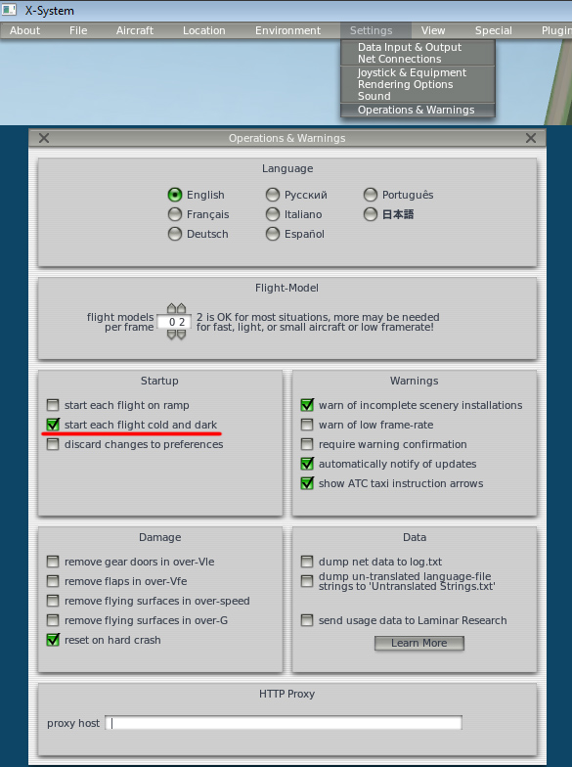

Moving in cockpit
The cockpit in this Tu-154M model is almost fully functional and modeled exactly, like in real world aircraft EW-85748. All panels and switchers are located at the same places, where they are in the real airplane, which is not useful for single-player simulator. But there is a simple cockpit navigation feature in X-Plane10. To activate it, you need to press Shift+8 – this will activate a free camera mode in the cockpit. To move it around, use the arrow keys, along with «,» and «.». To rotate it - Q E R F or the right mouse button.
Also there is a good feature in X-Plane10, that allows you to save camera position in cockpit. To save care position, you need to press Ctrl + some number key on the numpad. And to move camera to those saved positions – you just press the corresponding numbers on the numpad.

Changing language of panels and settings reset
This project has two languages variants, both Russian and English. To switch is, you need to open the Ground Service panel and just press Change language button. Model's logic continuously saves the current state of the aircraft, including selected language.
Also the systems saves position and sizes of 2D panels. All these data are stored inside two files: «saved_state.ini» for storing aircraft's state and «panels.txt» for 2D panels. To reset state, you can just delete those files.
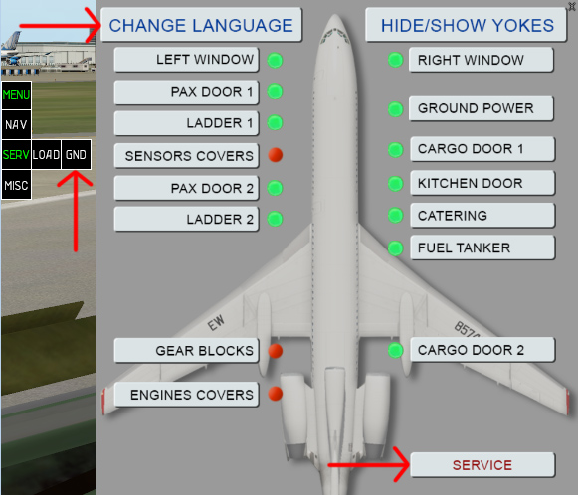
Also there is a «Serivce» button, used for «repairing» the aircraft – resetting failures and oil levels.

Setting up joystick buttons
To set up various commands to joystick buttons, you need to open menu Settings – Joystick & Equipment and select «Buttons:Adv» tab there. Then you'll need to press the button, you want to modify and select function for it. Also you can set up any custom commands. To do so, you can either copy the command into command entry field or press the button near it and select needed command from the list.
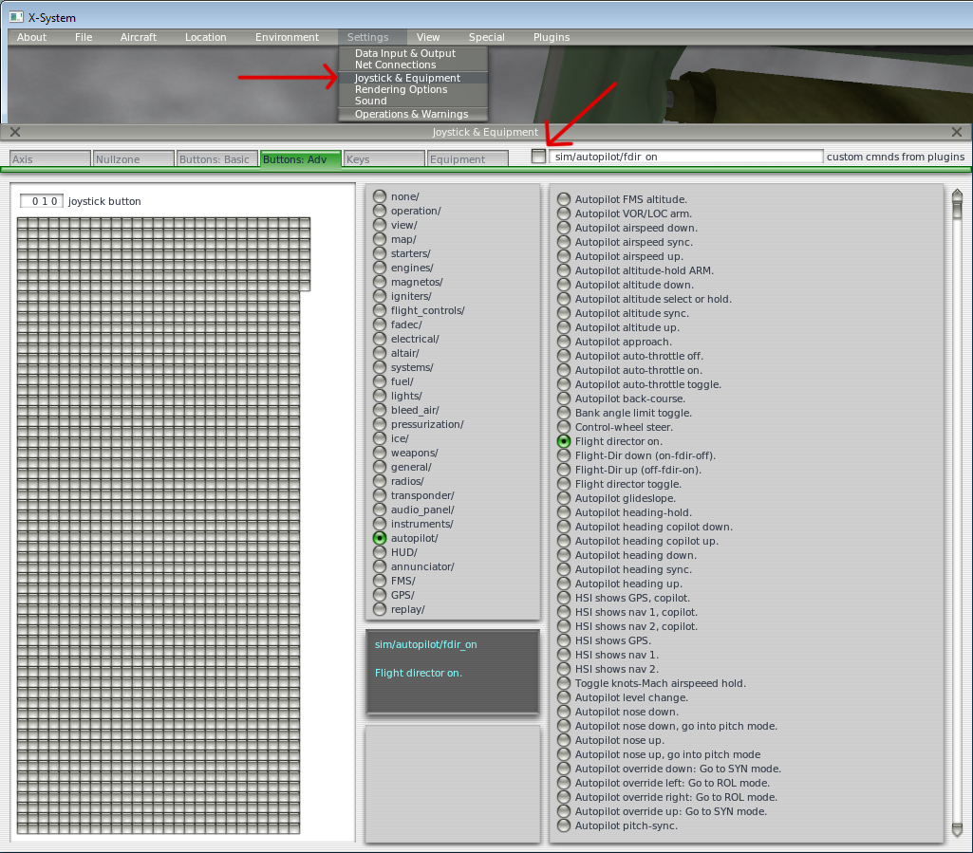

Commands list
Autopilot
sim/autopilot/fdir_on STAB mode
sim/autopilot/fdir_toggle STAB mode OFF
sim/autopilot/heading Couse Selection (SC) mode
sim/autopilot/NAV NAV mode (NVU)
sim/autopilot/airspeed_sync Stab V mode
sim/autopilot/level_change Stab M mode
sim/autopilot/altitude_hold Stab H mode
sim/autopilot/approach APP mode
sim/autopilot/glide_slope GS mode
sim/autopilot/nose_down Turn pitch wheel down
sim/autopilot/nose_up Turn pitch wheel up
sim/autopilot/override_left Turn roll handle left
sim/autopilot/override_right Turn roll handle right
sim/autopilot/wing_leveler Set roll handle to zero position
sim/autopilot/heading_down Turn left HSI course selector left
sim/autopilot/heading_up Turn left HSI course selector right
sim/autopilot/heading_copilot_down Turn right HSI course selector left
sim/autopilot/heading_copilot_up Turn right HSI course selector right
sim/autopilot/autothrottle_toggle Turn On/Off autothrottle
sim/autopilot/airspeed_down AT speed down
sim/autopilot/airspeed_up AT speed up
sim/engines/TOGA_power Activate TOGA mode
Lights
sim/lights/nav_lights_toggle Navigation lights On/Off
sim/lights/strobe_lights_toggle Red beacons On/Off
sim/lights/spot_lights_toggle Tail logo On/Off
sim/lights/landing_lights_toggle Landing lights extend/retract
sim/lights/landing_lights_on Landing lights mode up
sim/lights/landing_lights_off Landing lights mode down
Landing gears
sim/flight_controls/landing_gear_up Move LG lever up one step
sim/flight_controls/landing_gear_down Move LG lever down one step
sim/flight_controls/landing_gear_toggle Switch LG lever UP one step, if gear deployed, or DOWN if gear retracted
sim/flight_controls/nwheel_steer_toggle Turn ON/OFF nose-wheel turning mechanism

